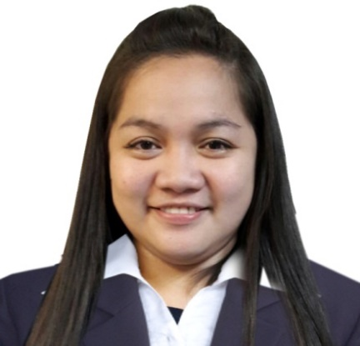**JOSEPHINE FERNANDEZ-ACOMPANIADO**

#2075 Jimenez St. San Andres Bukid, Manila x

0995-981-2189

[jfacompaniado@gmail.com](mailto:jfacompaniado@gmail.com)

­­­­­­­­­­­­­­

Objective :

To be able to acquire knowledge/skills so as to be qualifiedto perform in certain department, as well as in the other work opportunities and explore myself in different types of job opportunities thus to upgrade and update my knowledge.

**Professional Experience :**

**Accutemps Inc. / Radiowealth Finance Company Accounting Staff Jan. 2017-Present**

* Account Payable Recon Section - Jan. 25, 2017 to June 15, 2017
* Take various request for Customer Processing Fee of Client
* Prepare Journal Entries Monthly
* Account Receivables Section – June 16, 2017 to Present
* Handling Account Receivables of 17 Branches
* Validates & encode if necessary all branches transactions.
* Support Branches in various adjustment of customer accounts.
* Maintain Series Control of accountable Form.

**Pointer Enterprises, Inc. Accounting Staff Feb. 2013 – Jan. 2017**

* Prepares Sales Invoice of Daily delivery
* Sales Report Every Saturday.
* Encode Sales Invoice in System (PRINCES)
* Encoding of Weekly Petty Cash in Systme (PRINCES)
* Encoding of for release cheque of supplier.

**Pointer Enterprises, Inc. Typist (Data Encoder) Oct. 2012-Feb. 2013**

* Prepare Daily Quotation for Customer
* Maintain Filling of all quotation requested by the customer

**Slithor Enterprises, Inc. Office Clerk/Secretary May 2012-Oct. 2012**

* Answer telephones, direct calls and take messages.
* Sales Support
* Communicate with customers, employees, and other individuals to answer questions, disseminate or explain information, and address complaints.
* Compile, copy, sort, and file records of office activities, business transactions, and other activities.
* Operate office machines, such as photocopiers and scanners, facsimile machines, voice mail systems and personal computers.
* Compute, record, and proofread data and other information, such as records or reports.
* Maintain and update filing, inventory, mailing, and database systems, either manually or using a computer.

**One Source Facility Services/ Café Josefina Cashier Dec. 2010-Sept. 2011**

* Prepare Daily Sales Report
* Handle cash transactions with customers using cash registers
* Take and fill orders
* Manage large sums of money daily

**Educational Attainment:**

Tertiary: Universidad de Manila 2006-2010

(Former City College of Manila)

Bachelor Business Administration Major in Management

Secondary: Lakan Dula High School 2002-2006

Primary: Jose P. Rizal Elementary School 1996-2002

**On The Job Trainee**

Phillippine Postal Bank Inc. (Head Office) 150 Hrs.

Inland Corporation (Intramuros) 150 Hrs.

**Personal Data:**

Date of Birth: July 01, 1990 Place of Birth: Manila

Height: 5’2 Weight: 70kg

Citizenship: Filipino Religion: Roman Catholic

Civil Status: Married

**Special Skills**

* Knowledge in MS Office Application
* Organized Thousands of records and managed filling system

Containing confidential Information.

* Can work under pressure
* Positive Attitude

I hereby certify that the above information is true and correct to the best of my knowledge and

Beliefs.

Josephine F. Acompaniado

Applicants